CS4471 Lab Assignment 6

Spanning Tree Protocol (version 1.0)

Use Cisco Packet Tracer program to create the network shown below containing 3 interconnected Ethernet switches and 3 computers.

- configure the hostnames as shown for all six devices

- configure each switch port shown to be in vlan 2

- configure IP address and subnet mask of all six devices as shown

- interconnect the six devices with appropriate Ethernet cables and verify that all six links are up

- verify that from PC1, you can ping the IP address of the other five devices

- configure spanning-tree priority of each switch with values shown.

1. (20 pts) submit screenshot of Cisco Packet Tracer network diagram created. Make sure that the port labels are shown (Options->Preferences->Show Port Labels)

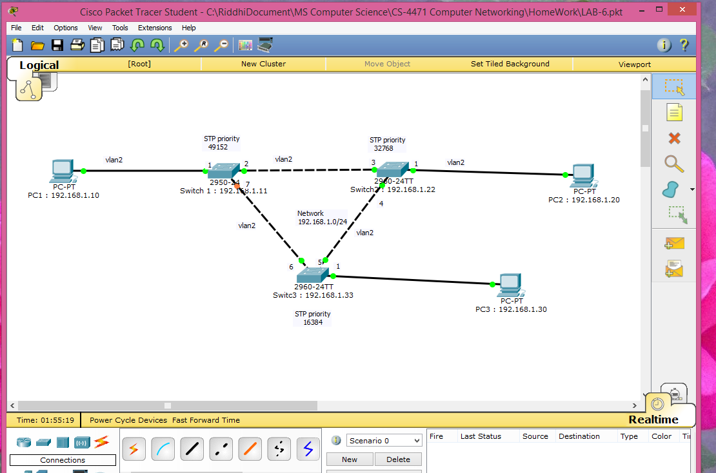

1. (30 pts) submit printout of output of “show running-config” of each switch

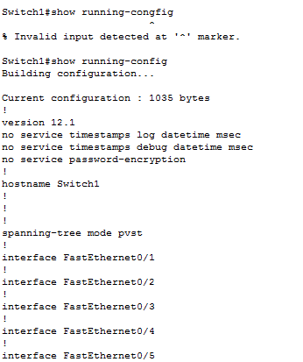

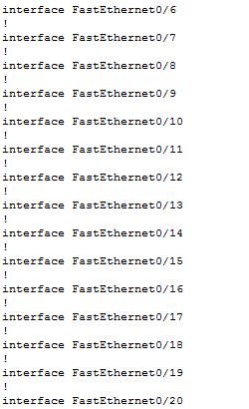

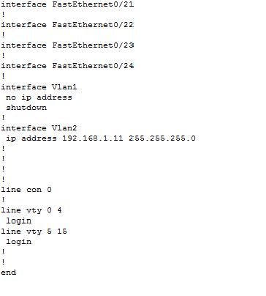

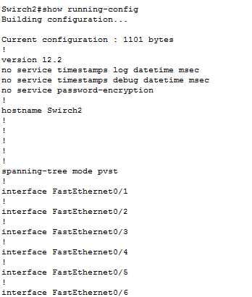

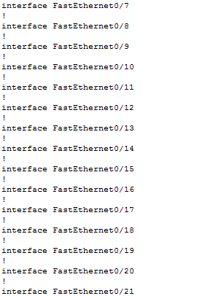

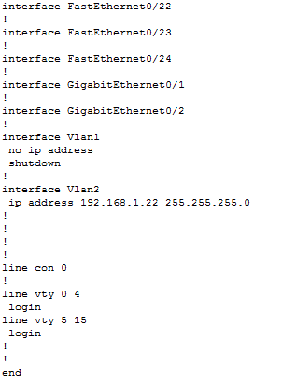

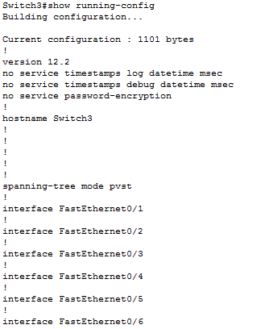

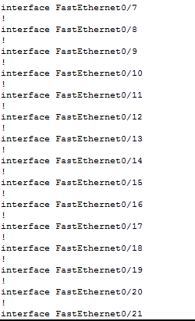

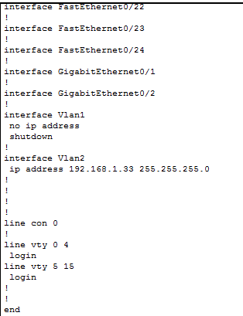

3. (50 pts)

1. which switch is the root bridge and which switch ports will become a Spanning-Tree Protocol root port?

Ans : **Switch2** is the root bridge and

b. which switch port(s) will Spanning-Tree Protocol place into forwarding state?

c. which switch ports(s) will Spanning-Tree Protocol place into blocking state?

d. If PC1 were to send ICMP ping packets to PC2, which network links will the packets traverse?

e. what will happen to the port originally in STP blocking state when a STP root port is administratively shutdown ?